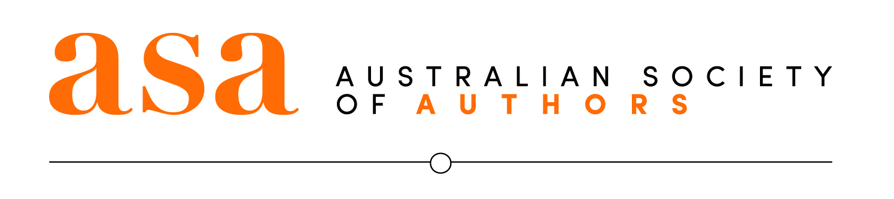

**Australian Society of Authors Treasurer’s Report**

**Report on the annual accounts for the year July 1, 2017 to June 30, 2018.**

I am pleased to present the Annual General Meeting’s Treasurer’s report for the year to June 30, 2018. This is the first year in which we report to a full June 30 financial year and follows a transition from an 18-month reporting period.

It has been a very busy and satisfying year for the ASA. The continued loss of Australia Council grant funding took its toll on working capital, but the ASA responded by streamlining processes and emerged a leaner, stronger organisation. Its commitment to enhancing member services was also rewarded by an increase in membership. The ASA has not only weathered this challenge, it has become much less dependent on grant funding, ensuring its continued independence as Australia’s leading advocate for authors’ rights.

The ASA’s property at Pitt Street, Redfern, was liquidated to realise the strong capital growth that had been achieved. An appropriate amount was set aside for working capital, and the bulk of the proceeds will be invested in perpetuity on behalf of our members.

Memberships numbers rose over the year, reflecting the ASA’s success in developing and expanding its services to members in a manner that meets the demands of a rapidly changing industry.

On present trends, and in light of the June-year financial result and membership forecasts for 2019, the 2018-19 budget appears achievable. We are on firmer ground across nearly all metrics, including cash flow, staff-to-income ratios, and membership figures. Over time, we will also build investment income from the Pitt Street proceeds, giving the ASA further resources to develop services for members.

The accounts are in a very good state, thanks to:

* the adoption of the Xero accounting software, which has enabled easy monthly reporting of financials;
* tight control of expenditure and removal of some big expenses such as IT support;
* a reversal of a working capital drought thanks to the sale of Pitt Street; and
* the separation of grant money from operating funds.

The auditors have given the organisation a clean bill of health and commented on the substantial improvement on the presentation of the financial records, and commended the ASA’s new treatment of grant funds.

**Highlights**

* The organisation posted an operating profit of $27,778. This is $35,861 ahead of a budgeted loss of $8,083.
* Income from activities rose sharply to $132,669, against a budget of $107,787 (up 23%), thanks to a strong performance from:
* professional development (up 74% against budget); and
* mentorships (up 53.4% against budget).
* Membership income was 4.3% down on budget ($20,536) due to a variance in the phasing of new member income.
* Total expenses were $689,758, $39,064 less than forecast (down 5.4% against budget) – an excellent figure – thanks to:
* lower staff expenses (down $21,000 or 4.5%)
* a fall in office and general expenses (down $6,046 or 7.7%)
* a fall in total administration costs (down $49,931, or 9.2%).
* Total income was $3,203 less than budget.
* Membership numbers grew by 145 members over the financial year from 2,470 at July 1, 2017 to 2,612 as at June 30, 2018.
* As at June 30, 2018, cash in the trading bank account stood at $142,573.
* Working capital of $40,000 has been repaid and the annual drawdown was $45,000 less than forecast. This is a very pleasing outcome.
* The working capital requirements on the cash flow forecast for the new financial year is $120,00, within the approved allowance of $150,000.
* This is the first year to the CEO’s knowledge, that the grant cash has been separated from normal operations, with the balance of unspent money kept in the grants account until required. This totaled $51,715.69 at year end. This is an excellent outcome from a fiduciary perspective.
* **Assets and liabilities:** Net assets and total equity stood at $1,748,716. Liabilities outside of grants ($51,715), and memberships, were zero.
* **Staff levels:** The staff-to-income ratio is used to determine optimal figures for growth. The ASA’s staff-to-income ratio is roughly 22%. A figure between 20% and 30% is considered optimal to drive growth. An average of $156,000 in income was generated by each FTE (Full-Time Equivalent) – a significant increase on prior years.
* **Investment Committee:** A new committee has been formed to oversee the ASA’s three major investments: The Barbara Jefferis Award Fund, the Endowment Fund and the soon to be set up Investment Fund which will be comprised of the gains made on the Pitt Street property. This committee is made up of three ASA directors, and two individuals with strong financial management backgrounds.

Please note that an audit of the Barbara Jefferis Fund is under way, but as this is a separate entity, it was not ready in time for this AGM. The audit report will be posted on the website shortly.

**Conclusion**

It has been a very busy year, and as Treasurer for the past 6 months, I would like

to thank the management and staff of the ASA who have been providing excellent value to our members. They have been working tirelessly to develop new services while managing major upheavals on the members’ behalf, such as the liquidation of Australia’s largest independent book publisher, Dennis Jones, and the copyright battles that were raging throughout 2017. It is an organisation we can all be proud of.

Given the loss of Australia Council grant funding, which has caused great disruption to the ASA’s operations over the past two years, the board has made strong steps towards becoming self-sustaining, and restructuring its business model to one that is less grant dependent. Management’s performance against budget under challenging circumstances during this period of restructuring was impressive.

Sarah Mills

Treasurer

25 October 2018